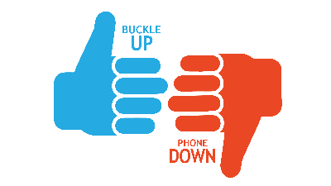

Buckle Up Phone Down Talking Points
- [BUSINESS/ORGANIZATION] believes the safety and well-being of our employees and community is very important. We are challenging our employees to buckle up and put their phones down every time they drive.
- [BUSINESS/ORGANIZATION] is working alongside Vision Zero in helping to reduce motor vehicle crashes, injuries and fatalities associated with distracted driving due to mobile electronic devices and unrestrained occupants through the Buckle Up Phone Down (BUPD) initiative.
- The Vision Zero BUPD program creates awareness of the two most important actions a driver can take to prevent and survive a crash: Use your seat belt every time you’re in a vehicle and put your phone away to keep your attention on driving.
- Distracted Driving is a leading cause of crashes in the United States and claimed 3,142 lives in 2020. (NHTSA)
- Distracted driving is vastly underreported as a factor in a crash due to driver hesitancy to report, lack of witness verification and other factors resulting in limited data in North Dakota. However, in 2021, 1,027 distracted driving violations were posted to the ND Driver’s License system. (NDDOT Crash Summary)
- 2021 data shows that nearly 67% of motor vehicle fatalities in North Dakota were unrestrained. (NDDOT Highway Safety Division)
- Seat belts are the single most effective safety device in your vehicle to help prevent and reduce the severity of injury or death in a motor vehicle crash.
- We will be sharing “thumbs up/thumbs down” photos on social media and with Vision Zero to show our support using the hashtag #NDBUPD.
- For more information on ways to participate, visit VisionZero.ND.gov

