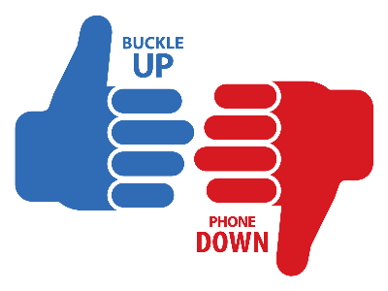

Sample Buckle Up Phone Down Social Media Posts
Consider using the posts below on your various social media accounts or use them as inspiration to create your own! Download the available graphics from the Vision Zero website, take your own thumbs up/thumbs down photo or use the BUPD logo to create your own graphic to accompany the text. Don’t forget to use the hashtag #NDBUPD.

We are committed to getting our employees home safe to their families. That’s why we joined @VisionZeroND in the Buckle Up Phone Down challenge. We #BUPD for #NorthDakota! #NDBUPD

The safety of our team members is a top priority. In partnership with @VisionZeroND, we are encouraging everyone to buckle up and put the phone down. #NDBUPD

Did you know nearly 67% of motor vehicle fatalities in North Dakota in 2022 were not wearing a seat belt? We’re committing to #NDBUPD by buckling up and putting the phone down – every trip, every time!

When it comes to the lives of our employees, customers and fellow North Dakotans, zero is the only acceptable number of motor vehicle fatalities. That’s why we #BUPD for #NorthDakota! @VisionZeroND #NDBUPD

Sending a text while driving 55 mph is like driving the length of a football field BLINDFOLDED. Let’s all do our part to save lives by buckling up and putting the phone down. #NDBUPD @VisionZeroND

Two things you can do to decrease the number of motor vehicle crashes in North Dakota: buckle up and put the phone down. Join us by taking the #NDBUPD pledge! @VisionZeroND

