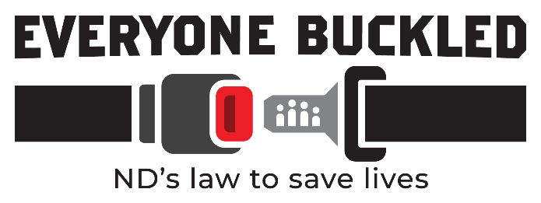

Primary Seat Belt Law Talking Points
What is the change to North Dakota’s seat belt law?
Beginning Aug. 1, 2023, the seat belt law becomes a primary enforcement, meaning no other violation is required for a driver to be pulled over by law enforcement and issued a seat belt citation. The law will also require all occupants to wear a seat belt, regardless of where they are sitting in the vehicle.
- A primary seat belt law has a greater effect on reducing deaths and nonfatal injuries than a secondary law.
- Research shows increased seat belt use with a primary law vs. a secondary law can result in up to a 10-12% increase in observed seat belt use. (NHTSA)
- Switching from a secondary law to a primary law reduces passenger vehicle driver deaths by 7%. (NHTSA)
- Seat belt use is lower in states with secondary enforcement seat belt laws, or no seat belt laws compared to states with primary enforcement laws. (NHTSA)
- This primary seat belt law does not represent a new law, it simply changes existing North Dakota law as follows:
  - Changes enforcement from secondary to primary.
  - Changes the requirement for seat belt use from front seat occupants to ALL occupants.

Why was the existing law changed?
To save lives. The number one contributing factor in motor vehicle crash deaths in North Dakota is not wearing a seat belt.
- Preliminary data for 2022 shows that 69% of crash fatalities were unbelted where seat belts were present in the vehicle.
- More people die in motor vehicle crashes in North Dakota from being unbelted than other common contributing crash factors such as drunk driving, distracted driving or speeding.
- A Primary Seat Belt Law will decrease motor vehicle crash deaths in North Dakota. Seat belts are the single most effective traffic safety device to prevent death and injury in a motor vehicle crash.
- From 2017-2021, 522 people died on North Dakota’s roads. Of those people killed in vehicle crashes where seat belts apply (excluding motorcycles, bicyclists and pedestrians), 51% were not wearing a seat belt. (NDDOT)

Does law enforcement need another reason to pull somebody over?
Response: Do not respond “no” to this question when asked. Say instead that “The change to primary enforcement of seat belts is about saving lives by making the current law more effective. It is not about giving law enforcement another reason to pull people over, rather, it’s to gain voluntary compliance so more people will wear their seat belt because they realize they can get pulled over for not wearing it.

Do primary seat belt laws infringe on individual rights?
Opponents often assert that highway safety laws violate personal choice and individual rights. However, driving on the public roadways is a privilege. Therefore, enforcing the seat belt law in the same manner as other traffic laws does not infringe on a motorist’s liberty.

