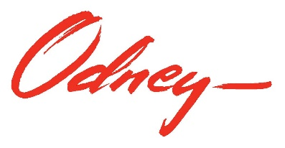

North Dakota Department of Transportation
Primary Belt Law Social Media Posts

- More people die in motor vehicle crashes in North Dakota from being unbelted than other common contributing crash factors such as drunk driving, distracted driving, or speeding. Learn more about the updated seat belt law going into effect August 1 in North Dakota. #PBLND #BuckleUp #EveryoneBuckled #SeatbeltsSaveLives #VisionZeroND
https://visionzero.nd.gov/strategies/OccupantProtection/law

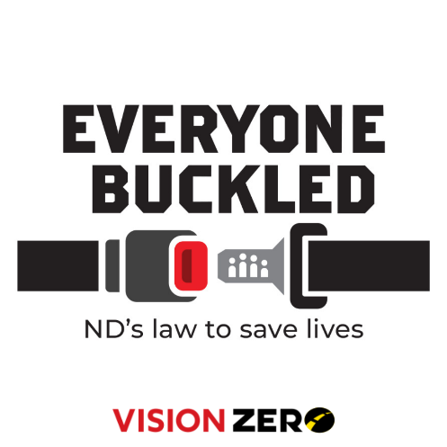

- Preliminary data for 2022 shows that 69% of crash fatalities were unbelted where seat belts were present in the vehicle. Our goal is to get to zero. The change to primary enforcement of seat belts is about saving lives by making the current law more effective. #PBLND #BuckleUp #EveryoneBuckled #SeatbeltsSaveLives #VisionZeroND
https://visionzero.nd.gov/strategies/OccupantProtection/law

- Have you heard about the Primary Belt Law going into effect this August? A primary seat belt law has a greater effect on reducing deaths and nonfatal injuries than a secondary law. Buckle up and help save lives. #PBLND #BuckleUp #EveryoneBuckled #SeatbeltsSaveLives #VisionZeroND

- Seat belts save lives. That’s the reason North Dakota’s law is changing from secondary enforcement to primary enforcement on August 1. Learn more about the change to this law on our site. #PBLND #BuckleUp #EveryoneBuckled #SeatbeltsSaveLives #VisionZeroND
https://visionzero.nd.gov/strategies/OccupantProtection/law

- The goal of zero fatalities on North Dakota roads is not only attainable, but also vital. When it comes to your life, or the lives of your family and friends, is any other number acceptable? We’re aiming for zero fatalities because every life matters.
A primary seat belt law gets us closer to our goal. #PBLND #BuckleUp #EveryoneBuckled #SeatbeltsSaveLives #VisionZeroND

